V(40"-79")

Large wedge type non through-hole power chuck (adapter excluded)
- Chucking operations of very large components external or internal clamping.
- Suitable for vertical lathe, due to the front protection of slide way.
- Master jaw with manual radial setting function.
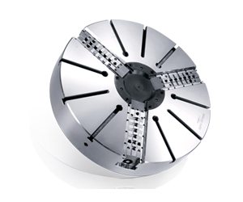
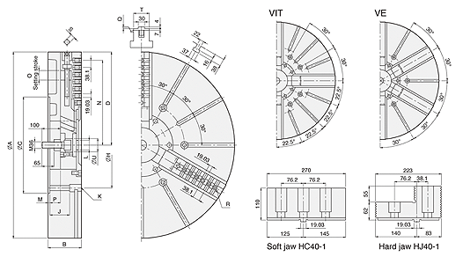
UNIT : mm
SPEC  Model | Jaws | Plunger  Stroke  (mm) | Radial Jaw  Stroke  +(Manual setting)  (mm) | Max.  Pull  Force  (kN) | Max.  Gripping  Force  (kN) | Max.  Operating  Pressure  (kgf / cm²) | Max.  Speed  (r.p.m.) | Weight  (kg) | Moment  Of Inertia  I  (kg‧m² ) | Matching  Cylinder | Matching  Hard Jaw | Matching  Soft Jaw | Gripping  O.D. Range  (mm)
40"V-240 | 3 | 57 | 23 + (30) | 180 | 320 | 42.8 | 630 | 645 | 82 | MS250C | HJ40-1 | HC40-1 | Ø285-Ø105
VIT-240 | 4 |  |  |  |  |  | 550 | 700 | 89
50"V-250 | 3 | 57 | 23 + (30) | 180 | 320 | 42.8 | 500 | 890 | 168 | MS250C | HJ40-1 | HC40-1 | Ø270-Ø1250
VIT-250 | 4 |  |  |  |  |  | 400 | 94 | 177
VE-250 | 6 |  |  |  |  |  | 360 | 971 | 183
63"VIT-263 | 4 | 60 | 24 + (40) | 200 | 360 | 46.9 | 300 | 1700 | 518 | MS250C | HJ40-1 | HC40-1 | Ø390-Ø1600
VE-263 | 6 |  |  |  |  |  | 280 | 1800 | 548
79"VE-279 | 6 | 60 | 24 + (40) | 200 | 360 | 46.9 | 230 | 2850 | 1350 | MS250C | HJ40-1 | HC40-1 | Ø440-Ø2000

DIM  Model | A | B | C | D  max. | H | J | K | L | M | N  max. | O | P  max. | P  min. | Q | R | S | T | U
40"V-240 | 1005 | 180 | 520 | 502 | 463.6 | 108 | M24 | M52x1.5 | 8 | 457 | 30 | 59 | 2 | 4 | 7-M24 | 19 | 85 | 72
VIT-240
50"V-250 | 1250 | 180 | 520 | 623 | 463.6 | 108 | M24 | M52x1.5 | 8 | 563 | 30 | 59 | 2 | 4 | 10-M24 | 19 | 85 | 72
VIT-250
VE-250
63"VIT-263 | 1600 | 220 | 720 | 796 | 647.6 | 144 | M30 | M52x1.5 | 8 | 738 | 40 | 82 | 22 | 6 | 13-M24 | 22 | 110 | 72
VE-263
79"VE-279 | 2000 | 238 | 720 | 996 | 647.6 | 159 | M30 | M52x1.5 | 8 | 914 | 40 | 100 | 40 | 6 | 17-M24 | 22 | 110 | 72

